Resources:

url: <http://psycnet.apa.org.ezproxy.library.uq.edu.au/fulltext/1993-15350-001.html>

such as employee commitment, adjustment, and stress. Research has shown some significant relationships between individuals' commitment and performance (Meyer, Paunonen, Gellatly, Goffin, & Jackson, 1989)

<http://psycnet.apa.org.ezproxy.library.uq.edu.au/fulltext/1989-20805-001.html>

The results of this study generally supported our predictions. Affective commitment of employees to a food services organization was positively related to their measured job performance, whereas continuance commitment was negatively related. The value of commitment to the organization, therefore, may depend on the nature of that commitment. When commitment reflects an identification with and involvement in the company, as conceptualized by Porter and his associates (e.g., Porter et al., 1974), the organization may benefit both in terms of reduced turnover and superior performance. In contrast, when commitment is primarily on the basis of a recognition of the costs associated with leaving, as Becker (1960) described it, the benefits of reduced turnover may be obtained at the price of relatively poor performance.

The satisfaction and attitudes of employees are important factors in determining their behavior and responses at work, and it is through these behaviors and responses that organizational effectiveness can be achieved. the satisfaction and well-being of employees can result in organizational effectiveness through salient productivity-related behaviors of employees

Kopelman et al. (1990) suggested three categories of pertinent behaviors for organizational effectiveness: attachment, performance, and citizenship. Attachment behaviors include attending to and staying in the organization.

Result: The strongest results were found for employee satisfaction; organizations with more satisfied employees tended to be more effective than organizations with less satisfied employees.

Resouce 2 (not-official)

https://prezi.com/s2ci3tebljgq/relationship-between-individual-and-organizational-values-an/

Job staticfaction affected by

* challenging work
* equitable(公平合理的 ) rewards
* supportive work environment and colleagues

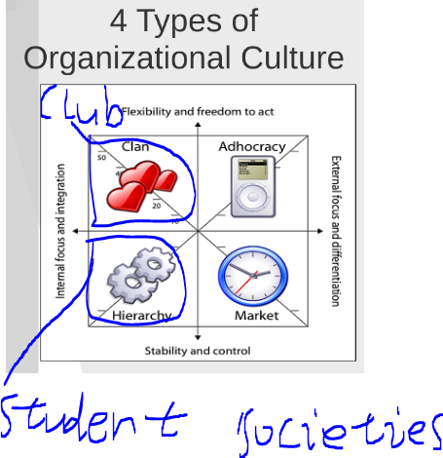

Resouce 3

<https://search-proquest-com.ezproxy.library.uq.edu.au/docview/1764139256>

Perceived Organizational Support

Perceived organizational support refers to how extensive an employee feels its company values their involvement within the organization and makes them feel taken care of and secure (Robbins & Judge 2015). Supportive working environments include fair reward systems, employees being an integral part in decision-making, and thoughtful and supportive management (Robbins & Judge, 2015). This is pertinent to business because a strong feeling of perceived organizational support increases organizational citizenship behavior and customer service, and decreases absenteeism and tardiness among all employees (Robbins & Judge, 2015).

Job satisfaction is positively correlated with perceived organizational support, organizational citizenship behavior, and task performance (Ren-Tao, 2011) In order to enhance employee performance, companies must implement policies and regulations, attitudes, procedures, and decision-making that takes into account the company's workers (Ren-Tao, 2011).

Employees value a relationship where benefits and contributions between the employee and company are equally exchanged (Ren-Tao, 2011)

Past studies have concluded that the higher the quality of leader-member exchange the more employees feel trust and respect for their employer which leads to organizational commitment while companies with low quality leader-member exchange do not feel an obligation to their employer and thus, see their jobs as a contractual agreement

# **Conclusions!!!!!!**

**Affective commitment of organizational members is positively related to their task performance(need reference)**

**Positive attitudes result in patterns that are directed toward achieving the organization's objectives( need reference)**

**attachment behaviours (attending and staying in the organization), role-prescribed behaviours (tasks in one’s organizational role) and citizenship behaviours (helpful contributions that are not mandatory)(reference https://bbs.pku.edu.cn/attach/82/a8/82a87209ed1ddf6a/13705862.pdf)**

**Job staticfaction affected by**

* **challenging work**
* **equitable(公平合理的 ) rewards**
* **supportive work environment and colleagues**

**Job satisfaction is positively correlated with perceived organizational support, organizational citizenship behavior, and task performance. Companies must implement policies and regulations, attitudes, procedures, and decision-making that takes into account the company's workers**(Ren-Tao, 2011)

**Employees value a relationship where benefits and contributions between the employee and company are equally exchanged (Ren-Tao, 2011)**

**higher the quality of leader-member exchange the more employees feel trust and respect for their employer which leads to organizational commitment**

Goal:

Enhance the relation between the student clubs and societies and also increase the effectiveness of student organizations.

Means:

By improving the members’ satisfaction to the organization and positive attitude.

How to improve members’ organization satisfaction?

1. **challenging work(task performance)(Big event, Regular classes, public service)**
2. **equitable rewards(voucher, vip, free BBQ etc)**
3. **supportive work environment and colleagues(perceived organizational support)**

**also related to organizational citizenship behaviour (组织公民行为)(thinking this is related to student organization but to specific)**

**For point 1: Affective commitment of members to the organization was positively related to their performance.**

**For point 2: Company must implement policies and regulations, attitudes, procedures, and decision-making that takes into account the company's workers**

**Employees value a relationship where benefits and contributions between the employee and company are equally exchanged (Ren-Tao, 2011)**

For point 3: Supportive working environments include fair reward systems, employees being an integral part in decision-making, and thoughtful and supportive management

Analysis:

Currently, our team are focusing on the problem of lacking connection between student organization and members which cause the issue of reduction of organization effectiveness. According to the research we’ve done, the key components will be improving members’ satisfaction to the organization and positive attitude. In this way, members will have stronger motivation to attend and perform organizational tasks and events, and the effectiveness of the student clubs and societies will be improved at meantime.

There are three important aspects to boost the members’ attitude and satisfaction which are challenging tasks commitments, equitable rewards and perceived organizational support. Due to the fact that accomplishing an assigned tasks or work is significant fulfilling and will bring the contributors strong sense of achievement, participants’ connection with the corresponding organizations is enhanced.

Additionally, organizations should establish policies and regulations, procedures, and decision-making system that can offer all members a balanced supportive environment. Under this circumstances, the organization will operate systematically and all members can receive equitable rewards since members value a relationship where benefits and contributions between the society and individual are equally exchanged. What’s more importantly, all members should be part of or related to the decision making of big events, leadership exchange etc… which can provide members supportive participating environment.

Possible solutions for our “app”

1. Create a Event platform for all the organization which helps them give all members a possibility of take part in the event.
2. A special section are provided for all members which contains all the documented club regulations, policies, rewarding system, etc…
3. Create a helping center or information sharing for each of the organization that used to improve the relation between individuals and offer a better support to all members.
4. Choice making system with certain issues like attending or holding big events, leadership exchange etc…
5. To be continue...